MFW4A Webinar Series
Summary Report
Title: Fintech sustainability in Africa – the impact of corporate governance and regulations
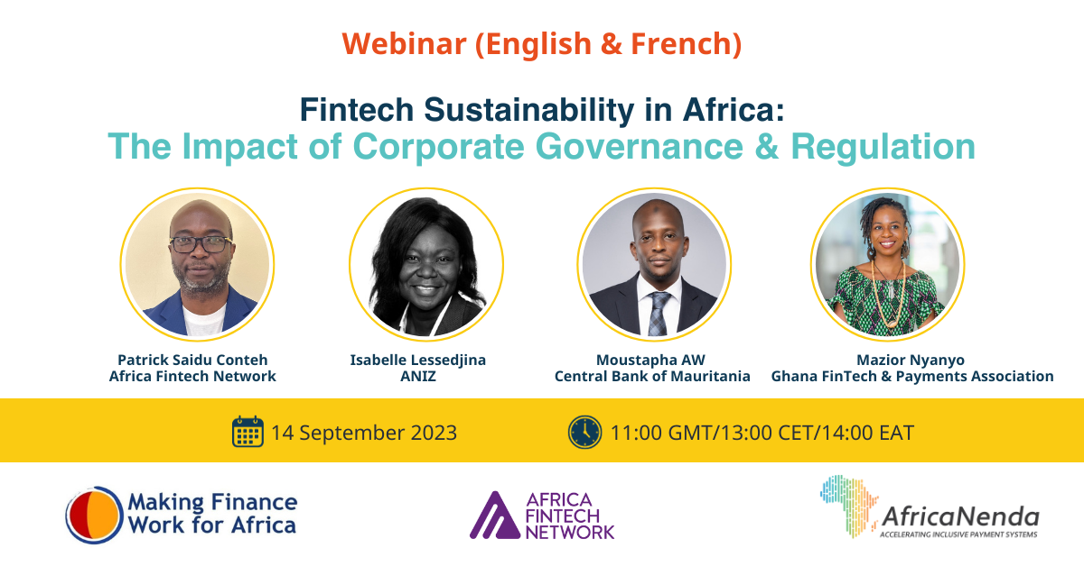

Patrick Saidu Conteh, CEO of Africa Fintech Network, was the facilitator of the main discussion.
Mauritania: a case study
First up was Moustapha AW, Director of Supervision and Regulation of Payment Systems, Central Bank of Mauritania. His presentation involved a case study of Mauritania, and its systems and methods of fintech management. It gave an overview of the fintech sector in Mauritania, the development of the regulatory framework for fintech, governance in the sector, risks and risk mitigation measures, and consumer protection. The case study provided detailed evidence of a sector that is growing, that has enormous economic potential, and the enormous progress that policy and regulatory authorities have made in their determination to supervise the sector effectively.
Navigating the Fintech Revolution in Africa: Policies, challenges, and regional initiatives
The next presentation was by Mazior Nyanyo, Vice President of Finance, Administration and Operations at Ghana Fintech and Payments Association, on the topic ‘Navigating the Fintech Revolution in Africa: Policies, Challenges, and Regional Initiatives’. She started off with this pithy definition – ‘Fintech in Africa is a dynamic fusion of finance and technology, sparking innovation and digital transformation across the continent – and with great innovation comes great responsibility, especially in the realm of corporate governance’.
The Fintech sector has grown dramatically in recent years, owing to factors such as rising mobile phone penetration and a growing young population eager to use digital financial services. African governments and regulators are finding themselves in a unique dance, crafting policies and regulations that encourage innovation while keeping a close eye on consumer protection and financial stability.
Ms Nyanyo went on to discuss the key challenges of fintech governance at its different stages of development. She gave a clear big-picture view of the governance challenges at each of the different stages.
- Seed stage challenges: Planting the seeds of governance: founders' dominance; compliance complexity; data security; and investor scrutiny.
- Growth stage challenges: Nurturing governance: Scaling operations; regulatory compliance; risk management; and talent acquisition.
- Maturity stage challenges: Harvesting governance success: board diversity; exit strategies; cultural preservation; and sustainability and social responsibility.
Some of the key regulatory actions to address these challenges include: cybersecurity, financial inclusion, harmonizing cross-border payment regulations, the development of regulatory frameworks to address the growing influence of the cryptocurrency market.
The central importance of collaboration among authorities, countries was stressed.
‘Achieving uniformity in fintech regulations across Africa is like herding cats. Different legal systems, economic conditions, and regulatory strengths create a patchwork of rules and approaches. Africa’s fintech stakeholders are collaborating and sharing their best practices to foster innovation while protecting consumers and financial stability.’
Discussion: Dealing with risks that the fintech sector poses
In the discussion that followed, it was noted that it is important to encourage innovation while protecting the system and consumers. The third panelist, Isabelle Lessedjina, Managing Partner at ANIZ, an advisory firm specializing in sustainability, financing and governance, noted that risks include fraud, and digital illiteracy among consumers. Good digital infrastructure is needed to bridge the digital divide, but she noted that fintech companies have generally been good at reaching the most digitally illiterate. But fraud is a big issue. Addressing this effectively involves managing operational risk. Regulators need to promote best practice and trust. A good and sound governance framework needs to be in place. All fintech startups need to join the fintech associations to ensure that they are implementing good practice. Here is the link to the recording and the slides.

